David Ciorra

Gabriel Sabattino

The Baseball Pitch

The World Series is one of the most famous and viewed sporting invents in the world, since the 1800 its been America's beloved national pastime with the game having such a simple objective; score more runs than your opponent. The idea is to hit the ball thrown at you as far as you can before running around 4 bases to complete a run. Yet, despite the games simplicity there are over a dozen different pitches and because of this our project will explore and compare two very diverse pitches; the fastball and curve ball. The question at hand is quite straight forward, how does the effect of spin (which differs depending on which pitch is thrown) effect the trajectory of the baseball while in the air. The second question would then undoubtedly be which of these two pitches are more formidable for the batter to hit.

We will be generating graphs that will show how some of the forces acting on the baseball affect the course of the baseball in air. One of the graphs will represent the effect that air resistance has on the ball’s final position. The velocity of a fast ball and how it changes due to the aforementioned air resistance will be graphed. Another graph that will be generated will represent the way in which the spin factor involved in a curveball affects its final position. The effect of a fastball can be seen through a graph representing Both these graphs will be calculated theoretically through our calculations and will be tested against actual data from professional baseball players and MLB scenarios.

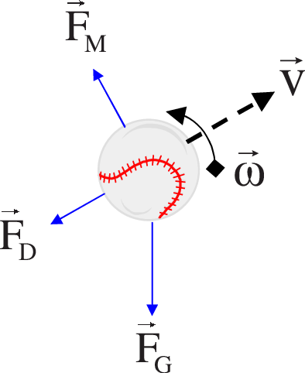

In the diagram above, Fg is the force of gravity defined as:

Fg= *(m × g)*

Where:

*M*=mass of ball

*g* =gravitational acceleration (9.8m/s2)

The opposing force to Fg is Fm (Magnus force). The Magnus Force is the lift on a ball or spinning object moving through a fluid.  Fm is defined as:

*Fm = S (w × v)*

Where:

*Fm* =the Magnus force vector

*w*= angular velocity vector of the object(rad/s)

*v=*Velocity of the fluid (or velocity of object, depends on perspective)  
  
*S=* air resistance coefficient across the surface of the object (Spin)

Perpendicular to the Magnus Force is Fd (Drag Force). Fd can be seen as air friction or air resistance. Causes the slowing down of an object. Fd can be defined as:

Fd = 0.5 x C x ρ x A x V2 

Where:

A = Area of ball.  
C = Drag coefficient (0.40).   
V = Velocity, m/s.  
ρ = Density of fluid (liquid or gas), kg/m3.

Opposite to Fd we have V(velocity) which is a measure of how fast something moves in a particular direction. V is defined as:

V=Vo + a x 

Vo= Initial Velocity

a=acceleration

= The time interval between the original and final situations.

Lastly, there’s angular velocity which is the rate of change of angular position of a rotating body. This is defined as:

W=V/R

Where:

W= angular velocity

V=linear Velocity

R= radius of ball

The graph of the curveball compared to the horizontal and vertical distance to the home plate will look like the graph below:

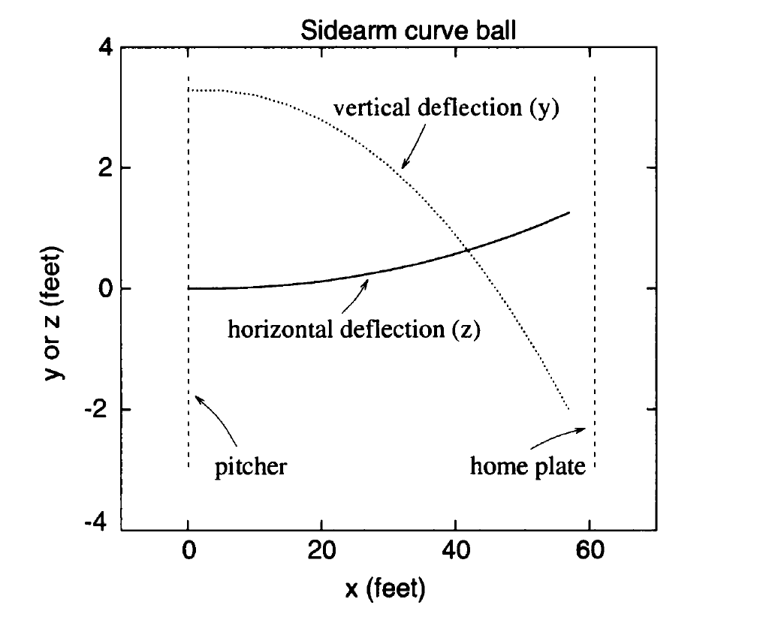link: <https://www.chegg.com/homework-help/questions-and-answers/calculate-position-trajectory-curveball-writing-matlab-program-plot-trajectory-baseball-th-q27526213>

A slight curvature occurs in both y and x axis when this type of pitch is thrown. The slight deviation can be found by applying the spin factor along with the other forces.

The graph below demonstrates how the fastball pitch looks like compared to the vertical and horizontal distances to the home plate. This graph also puts the curveball into perspective:

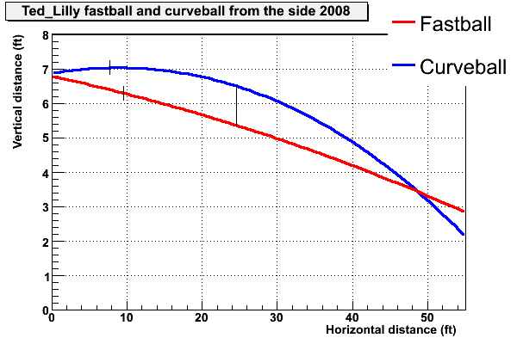

Link: https://tht.fangraphs.com/pitch-sequence-high-fastball-then-curveball/

It can be seen how the fast ball has more of a linear line which is easier to hit for the batter, taking into consideration the speed of the pitch, compared to the curveball.